Create RSS Datasets
This tool creates both the gSSURGO formatted File Geodatabase (FGDB) and open-source folder versions of a state Raster Soil Survey (RSS) database.
- For updates to state RSS datasets
  - the previous year’s dataset is required.
  - If any spatial updates were made, whether map unit key values are being updated or new mapping added, then the respective MURASTER and SARASTERS should be added. Note, that this tool will perform the mosaic for you to the previous year’s rasters. Any pixels from the previous year’s raster that are overlapped by update rasters will be stamped over with the update raster values.
  - SARASTER should rarely be updated and National Operations staff will provide that update raster.
- For the first year publication of a state RSS dataset
  - Only the tabular data is needed, not the previous year’s FGDB.
  - All three rasters will be required as inputs
Parameters:
- Tabular Folder of Exported SSURGOP Text files (required)
  - This is always required to build the coming fiscal year’s state RSS databases. This is exported by the State Soil Scientist and provided to the Regional GIS Specialist.
  - Every year, even when RSS mapping wasn’t directly updated, this must be provided as updates to interpretations or other elements of NASIS typically occur on an annual basis.
- Output Folder (required)
  - The location where the state RSS database will be created
  - Bot the FGDB and open-source versions will be saved in a new folder with the state abbreviation within this output folder. If one already exists, it will be overwritten.
- Select State (required)
  - The state for which the RSS dataset is being built
- First year of publication? (required)
  - Defaults as false.
  - This parameter sets the conditions for the next parameters
- Last FY’s RSS FGDB (conditional)
  - It is the FGDB version of the state RSS database
  - If the First year of publication (FYOP) is false (unchecked) then this is required. If FYOP is checked, then this parameter is turned off.
- Updates to MURASTER (as .tif) (conditional)
  - Either new mapping or updated mukey values to the MURASTER.
  - These rasters do not need a raster attribute table (RAT) nor do they need to be named in any way.
  - Multiple rasters can be added as this tool will mosaic for you. The order matters, values from the last raster listed takes precedence.
  - When FYOP is true, a raster must be provided
- Updates to PARASTER (as .tif) (conditional)
  - Either new mapping or updated laokey values to the PARASTER.
  - These rasters do not need a raster attribute table (RAT) nor do they need to be named in any way.
  - Multiple rasters can be added as this tool will mosaic for you. The order matters, values from the last raster listed takes precedence.
  - When FYOP is true, a raster must be provided
- Updates to SARASTER (provided by NSSC) (conditional)
  - This raster represents the extent of the state, represented by the RSS legend key.
  - This raster does not need a raster attribute table (RAT) nor does it need to be named in any way.
  - Only one raster can be provided.
  - When FYOP is true, a raster must be provided. Otherwise it is rarely updated.

Validate RSS Datasets
This validation tool performs high level quality checks of the RSS datasets. The following checks are run:
- Raster Naming Convention, the rasters have the following naming structure <base raster>_10m_<ST>_<FYYY> where the base raster is either MURASTER, PARASTER, or SARASTER, ST is the two-letter state abbreviation, FYYY is the fiscal year of publication. Open source GeoTiff of course have the .tif file extension.
  - PARASTER_10m_MN_2026
- Metadata, this only checks for the presence of an “.tif.xml” file for each of the three RSS rasters. It does not check these metadata files for completeness.
- Coordinate system is appropriate for the geographic region. For most states that is Albers Equal Area (epgs 5070)
- Band Count, there should only be one band for each raster
- No Data value should be 0
- Band Name, each band should be labeled denoting the raster values
  - MURASTER: MUKEY
  - PARASTER: LAOKEY
  - SARASTER: LKEY
- Text files/tables, the 69 SSURGO tables should be present
- Raster keys, all raster values should be present in the corresponding SSURGO table and vice versa
  - MURASTER values should correspond to a map unit key (MUKEY) in the mapunit table, and each MUKEY in the mapunit table should be represented in the raster
  - PARASTER values should correspond to a legend area overlap key (LAOKEY) of a Raster Soil Survey Project in the legend are overlap (laoverlap) table and each Raster Soil Survey Project LAOKEY in the laoverlap table should be represented in the raster
  - SARASTER values should correspond to a legend key (LKEY) in the legend table, and each LKEY in the legend table should be represented in the raster
- Raster topology, the non-no-data raster pixels should be appropriately overlap.
  - Each SARASTER pixel should overlap with a MURASTER pixel and vice versa.
    - PARASTERS pixels that do not have an overlapping mukey value in the MURASTER are identified in the PARASTER_exceed_MU.tif.
    - MURASTERS pixels that do not have an overlapping laokey value in the PARASTER are identified in the MURASTER_exceed_PA.tif.
  - The SARASTER pixels do not need to overlap a MURASTER or PARASTER as it represents the full extent of the state. But each MURASTER and PARASTER pixel must overlap with SARASTER pixel.
    - PARASTERS pixels that do not have an overlapping lkey value in the SARASTER are identified in the PARASTER_exceed_SA.tif.
    - MURASTERS pixels that do not have an overlapping lkey value in the SARASTER are identified in the MURASTER_exceed_SA.tif.
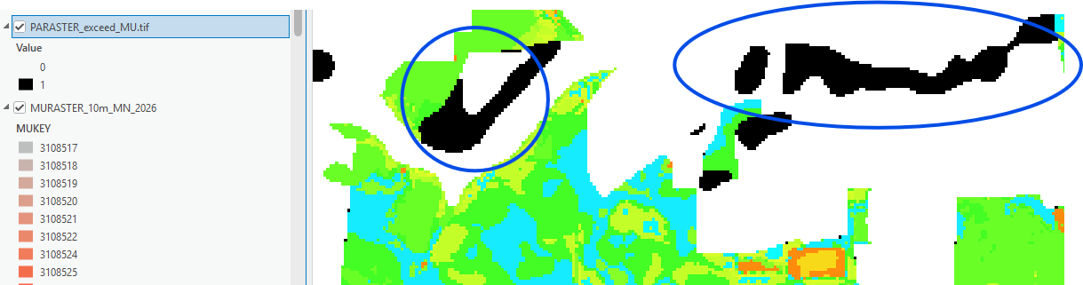
Figure 1. The pixels in black are areas not covered by MURASTER values but were identified as part of a Raster Soil Survey Project extent. Either these MURASTER pixels need to be infilled or the PARASTER needs to be masked to the actual extent of areas mapped.

